Step 1: Download and install DOCKER desktop

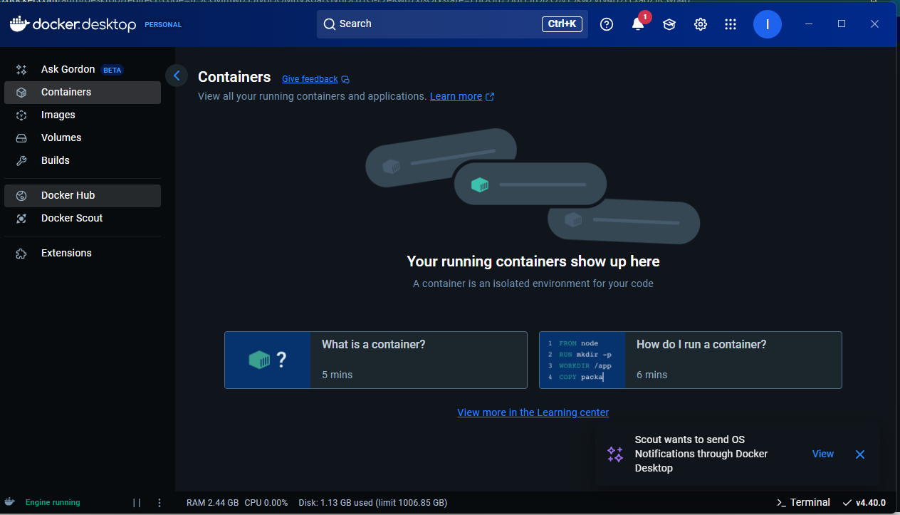

Step 2: RUN some basic Docker commands

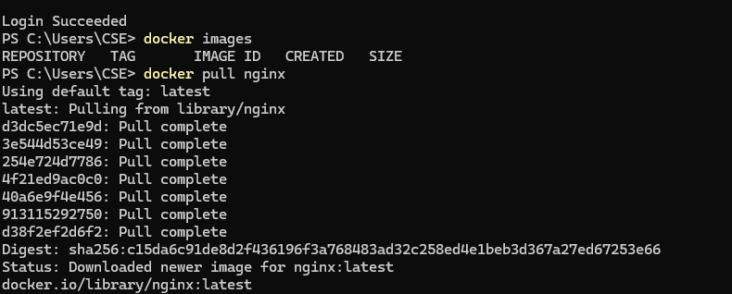

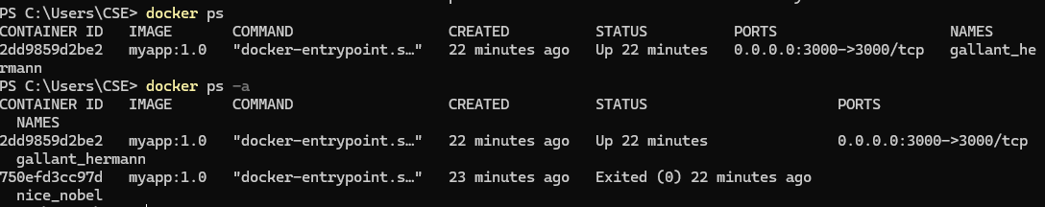

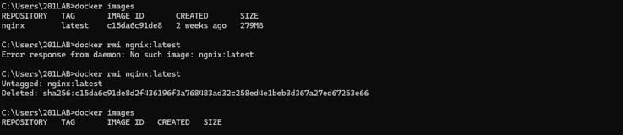

Step 3: Create a project on VSCode

Inside this folder, create two files:

* + **app.js**
  + **package.json**

Step 2: Add Code to package.json

In package.json, add the following content:

{

"name": "hello-world-app",

"version": "1.0.0",

"main": "app.js",

"scripts": {

"start": "node app.js"

},

"dependencies": {

"express": "^4.17.1"

}

}

App.js

const express = require('express');

const app = express();

const PORT = 3000;

app.get('/', (req, res) => {

res.send('Hello, World!');

});

app.listen(PORT, () => {

console.log(`Server is running on http://localhost:${PORT}`);

});

In terminal run : npm install

Step 4: Create a Dockerfile in the same project folder

# Use official Node.js runtime as a parent image

FROM node:14

# Set working directory in the container

WORKDIR /usr/src/app

# Copy package.json and package-lock.json

COPY package*.json ./

# Install dependencies

RUN npm install

# Copy the rest of the application source code

COPY . .

# Expose port 3000

EXPOSE 3000

# Run the app when the container launches

CMD ["npm", "start"]

Step 5 : Build a docker image

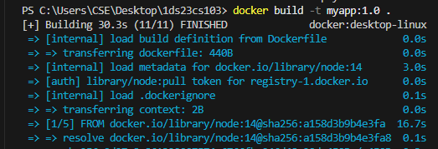

Step 6 : Run the Docker Container

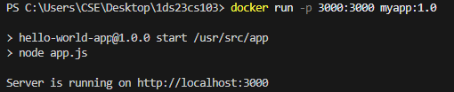

Step 7 : Access the Application by visiting

<http://localhost:3000>

Step 8 : The output should be

